**POSTMAN API TESTING**

Login Failed : <http://localhost:8080/api/v1/auth/login>

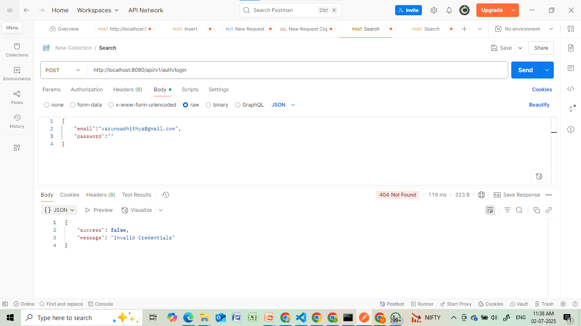

Registered Successfully : <http://localhost:8080/api/v1/auth/register>

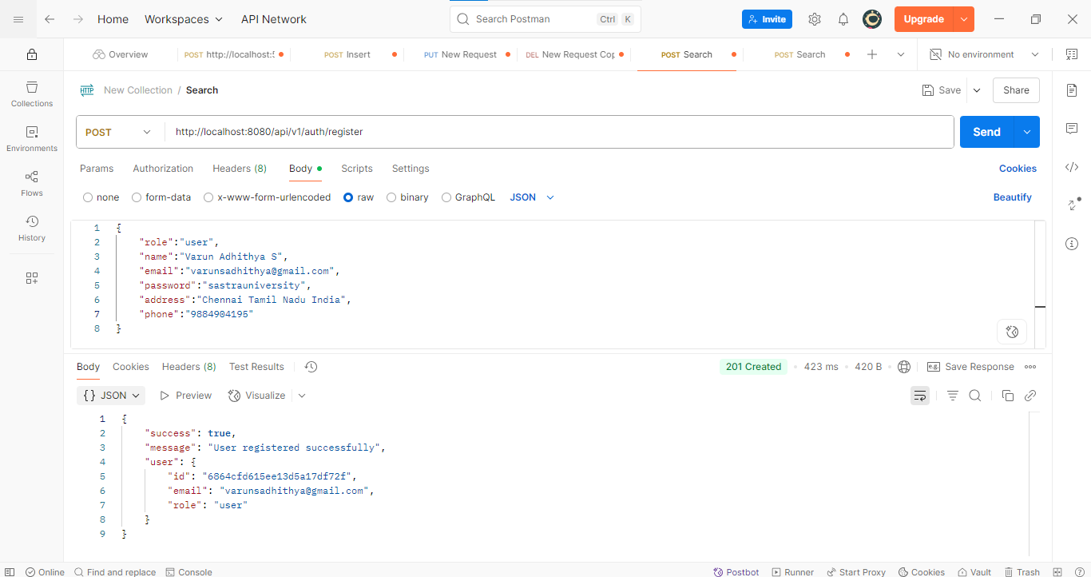

Login Successfully : <http://localhost:8080/api/v1/auth/login>

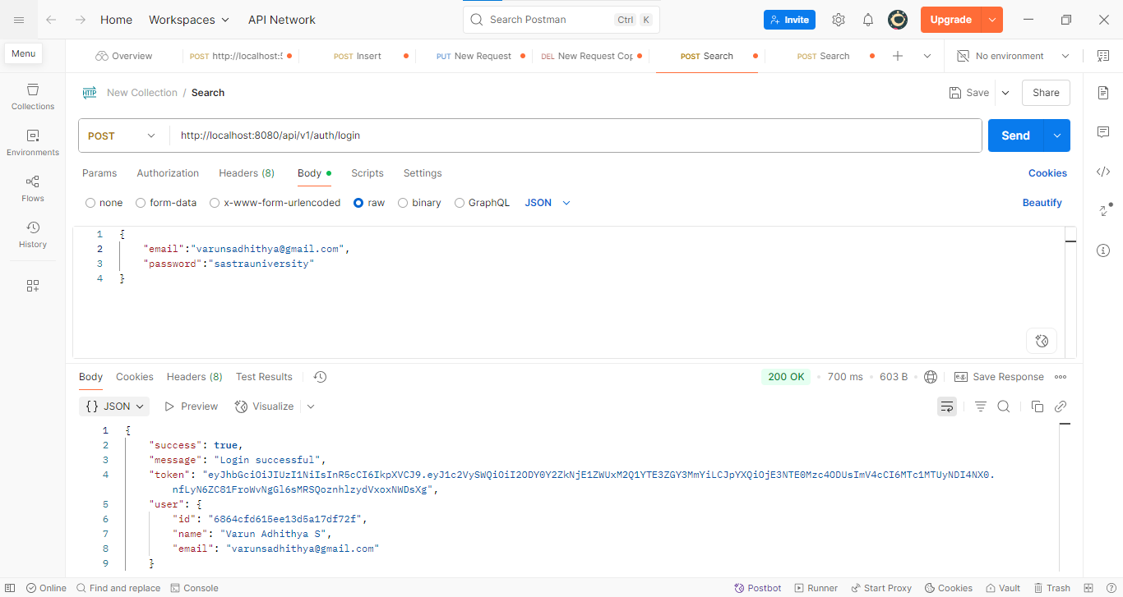

Get Current User : <http://localhost:8080/api/v1/auth/current-user>

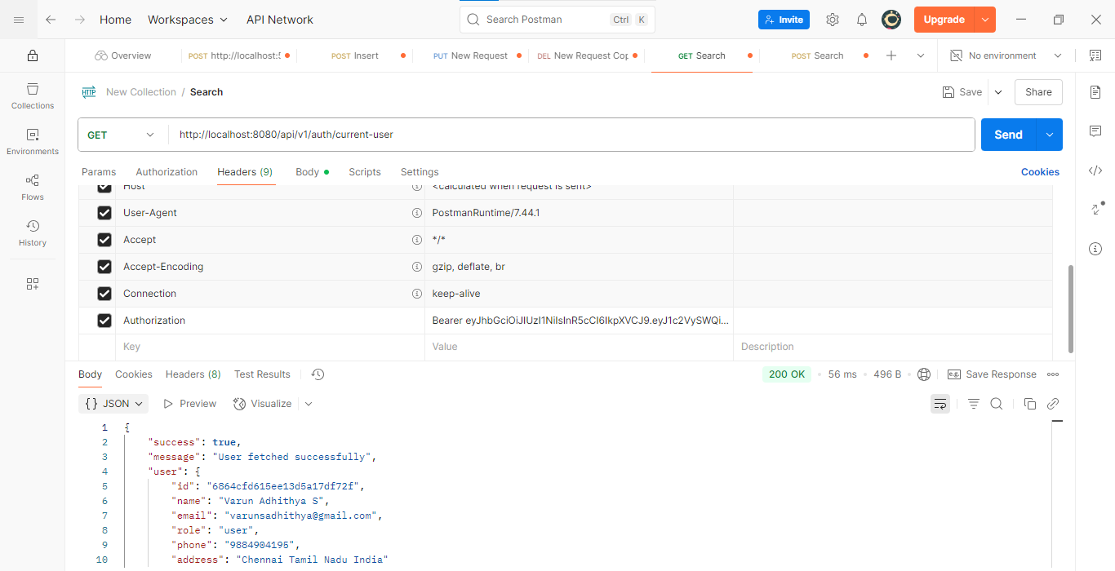

Create Inventory : <http://localhost:8080/api/v1/inventory/create-inventory>

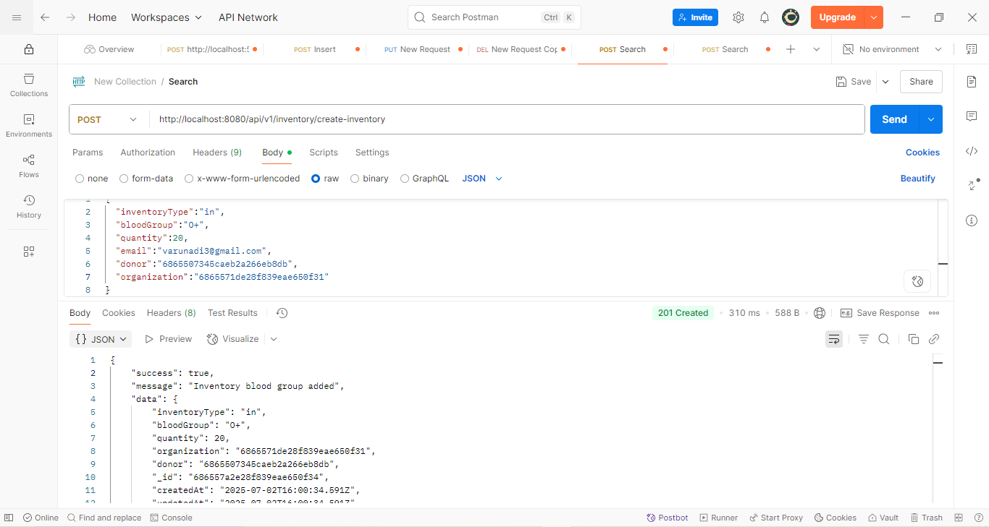

Registering Hospital : <http://localhost:8080/api/v1/auth/register>

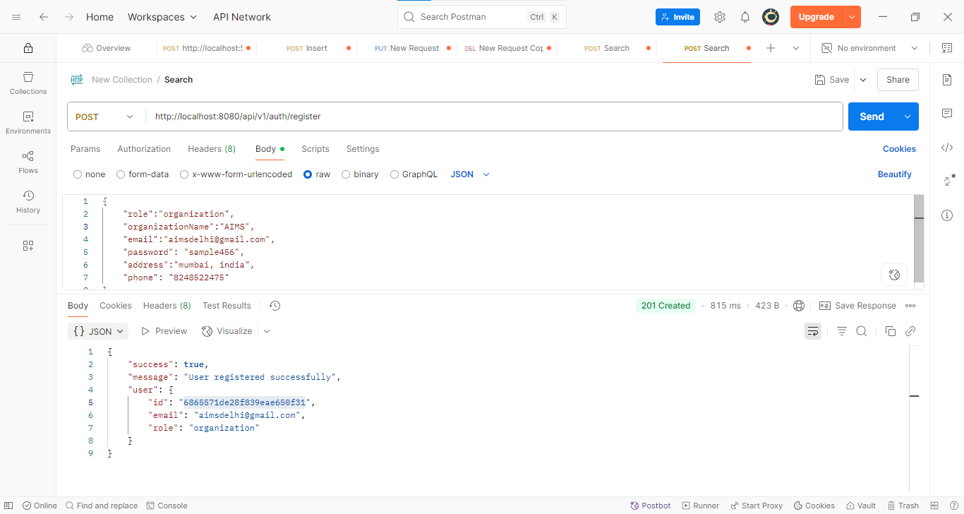

Get Inventory : <http://localhost:8080/api/v1/inventory/get-inventory>

